Deep Learning Fundus Image Analysis for Early Detection of Diabetic Retinopathy

1. Introduction
Project Title: Deep Learning Fundus Image Analysis for Early Detection of Diabetic Retinopathy
Diabetic Retinopathy (DR) is a leading cause of vision loss globally, affecting millions of people with diabetes. Early detection and treatment are crucial to prevent irreversible blindness. However, manual examination of retinal fundus images by specialists is time-consuming, subjective, and not scalable for large-scale screening programs.
This project addresses this critical healthcare challenge by leveraging deep learning to automate the analysis of retinal images, enabling rapid, accurate, and accessible early detection of diabetic retinopathy.
The project aims to develop an intelligent system capable of analyzing retinal fundus images and classifying the severity of diabetic retinopathy. By utilizing a pre-trained Xception model, a powerful convolutional neural network (CNN), the system learns to identify intricate patterns and abnormalities associated with DR, such as microaneurysms, hemorrhages, and exudates. This enables automatic grading of disease stages, from No DR to Proliferative DR.
The solution employs transfer learning, advanced data preprocessing techniques, and a Flask-based web application for deployment. Users can upload a fundus image and receive an instant, AI-powered analysis of the potential DR stage.
This practical application of deep learning in medical imaging offers a tool that can assist ophthalmologists, support large-scale screening initiatives, and facilitate remote patient monitoring. Ultimately, it has the potential to significantly improve patient outcomes by enabling earlier intervention and more efficient management of diabetic retinopathy.

Team Information
- Team ID: LTVIP2026TMIDS74884
- Team Size: 4
Team Members
- Team Leader: Vinod Kumar
- Team Member: Ulisetti Raja Babu
- Team Member: Bojanki Venkata Durga
- Team Member: Radhesh Yarlagadda

2. Project Overview
Purpose
To build a deep learning–based system that accurately analyzes retinal fundus images to detect and classify diabetic retinopathy, providing a scalable and accessible tool for early diagnosis.
Objective
To develop a deep learning-based system that predicts the presence and severity of diabetic retinopathy from retinal fundus images. The system aims to assist healthcare professionals in making faster and more accurate diagnoses, ultimately aiding in the prevention of vision loss.
Project Description
Diabetic retinopathy diagnosis through image analysis is a complex pattern recognition task. The subtle signs of the disease can be easily missed, and the process is labor-intensive for clinicians.
This project leverages:
- A public dataset of retinal fundus images (e.g., Kaggle’s APTOS 2019 Blindness Detection dataset).
- A pre-trained deep learning model (Xception) as a feature extractor.
- Transfer learning and fine-tuning techniques.
- A Flask-based web application for deployment.
The system processes an uploaded retinal image and predicts the corresponding diabetic retinopathy stage:
- 0: No DR
- 1: Mild
- 2: Moderate
- 3: Severe
- 4: Proliferative DR

3. Features
Data Preprocessing
- Resizing and normalizing images
- Data augmentation (rotation, zoom, flip) to improve model generalization
- Splitting data into training and validation sets
Deep Learning Model
- Base Architecture: Pre-trained Xception model (transfer learning)
- Custom classification layers added on top
- Trained on labeled retinal fundus images
- Model saved in .h5 format
Web-Based Dashboard
- Developed using Flask
- Simple, intuitive user interface
- Allows users to upload an image and view the prediction result
Real-Time Image Analysis
- User uploads a fundus image through the web interface
- Image is passed to the loaded Keras model for prediction
- Predicted DR stage is instantly displayed
Data Visualization
- Displays the uploaded image on the dashboard
- Shows the model’s prediction (e.g., Moderate Diabetic Retinopathy)
- (Optional) Confidence score for the prediction

3. Architecture
System Architecture
The system architecture of the Deep Learning Fundus Image Analysis project is designed using a modular approach. It consists of four main components:
- Data Layer
- Machine Learning Layer
- Backend Layer
- Frontend Layer
Each component works together to ensure accurate prediction and smooth user interaction.

3.1 Data Layer
Dataset
- Retinal fundus image dataset (e.g., APTOS 2019 Blindness Detection).
- Contains images labeled with 5 classes of diabetic retinopathy severity.
User Input
- Image file uploaded by the user through the web interface.
- The image is temporarily stored and processed for prediction.

3.2 Machine Learning Layer
Data Preprocessing
- Image resizing (e.g., 299×299 pixels for Xception).
- Pixel normalization.
- Data augmentation during training (rotation, zoom, flip).
Model Building & Training
- Base Model: Pre-trained Xception (weights from ImageNet).
- Technique: Transfer Learning (freezing base layers, adding custom top layers).
- Compiled with categorical cross-entropy loss and an appropriate optimizer.
Model Storage
- Trained model saved as .h5 file (e.g., Updated-Xception-diabetic-retinopathy.h5).
- Loaded during runtime for predictions on new images.

3.3 Backend Layer (Flask Application)
Responsibilities
- Render HTML templates for the user interface.
- Handle image upload requests.
- Load the pre-trained Keras model.
- Preprocess uploaded images (resize, convert to array, expand dimensions).
- Pass processed images to the model for prediction.
- Decode model output into a human-readable DR stage.
- Return prediction results to the frontend.
API Endpoints
- / (GET) → Renders the main upload page.
- /Predict (POST) → Accepts uploaded image, runs prediction, and returns result.

3.4 Frontend Layer
Technologies
- HTML
- CSS
- JavaScript (optional, for interactivity)
- Flask templates (Jinja2)
Dashboard Features
- Image upload form.
- Display area for uploaded image.
- Section to show prediction result.

3.5 Data Flow (Step-by-Step)
- User navigates to the web application homepage.
- User uploads a retinal fundus image file via the form.
- Flask backend receives the image.
- Image is preprocessed to match model input requirements.
- Pre-trained Xception model analyzes the image and generates a prediction.
- Prediction is mapped to a diabetic retinopathy severity class.
- Result is sent back to the frontend and displayed to the user.

3.6 Architecture Type
This project follows:
- Client–Server Architecture
- ML Model Deployment Architecture
- Web Application-based Communication
Frontend
- Flask templates (HTML, CSS) for UI design.
- Provides image upload form and result display.
Backend
- Python Flask application handling HTTP requests, preprocessing, model loading, and predictions.
Data Storage
- Image dataset stored locally in data/ folder for training.
- Trained model stored as .h5 file.
- No database used in this version (future versions may log predictions to a database).

4. Setup Instructions
4.1 System Requirements
Software Requirements
- Python 3.7 or higher (3.9+ recommended for TensorFlow/Keras compatibility)
- pip (Python package manager)
- Anaconda Navigator (recommended for environment management) with Spyder or PyCharm IDE
Python Libraries Required
- Flask
- TensorFlow (version 2.3.2)
- Keras (version 2.3.1)
- NumPy
- Pandas
- OpenCV-Python (or Pillow for image handling)
- h5py

4.2 Install Anaconda and Python
- Download Anaconda Navigator from the official website: https://www.anaconda.com/download
- Follow installation instructions for your operating system.
- Anaconda includes Python and many useful data science packages.

4.3 Clone or Download the Project
If using Git:
git clone <repository-url>
cd fundus-diabetic-retinopathy-project
Or download the ZIP file and extract it.

4.4 Create a Conda Virtual Environment (Recommended)
Creating a virtual environment keeps dependencies organized.
conda create --name dr_env python=3.8
conda activate dr_env

4.5 Install Required Dependencies
Navigate to your project folder in the Anaconda Prompt and install packages:
pip install numpy
pip install pandas
pip install tensorflow==2.3.2
pip install keras==2.3.1
pip install Flask
pip install opencv-python
pip install h5py
Verify installation:
pip list

4.6 Prepare the Dataset and Trained Model
- Dataset: Place training images in the appropriate folder structure (e.g., data/train/, data/validation/).
- Pre-trained Model: Ensure the file Updated-Xception-diabetic-retinopathy.h5 is in the root project folder.

4.7 Train the Model (If needed)
If the .h5 model file is not available or retraining is required:
python train_model.py
This script will:
- Load and preprocess the dataset.
- Build the Xception-based model.
- Train the model.
- Save the trained model as Updated-Xception-diabetic-retinopathy.h5.

4.8 Run the Flask Application
Start the backend server:
python app.py
Expected output:
* Running on http://127.0.0.1:5000/

4.9 Access the Application
Open your browser and go to:
http://127.0.0.1:5000/
You will see:
- The main page with an image upload form.
- After uploading an image, a results page displaying the prediction.
4.10 Testing the Prediction API
Using Postman:
- URL: http://127.0.0.1:5000/predict
- Method: POST
- Body: form-data with key file of type File, containing your fundus image

4.11 Stopping the Server
Press CTRL + C in the terminal where the Flask app is running.
- Folder Structure
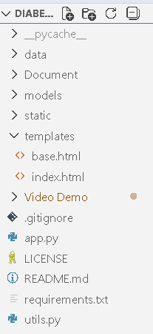

Main Project Folder
The project directory contains all essential files:
fundus-dr-project/
Key Files and Folders
- app.py
  - Main Python script.
  - Runs the Flask server.
  - Connects frontend (HTML) and backend (model).
  - Loads the trained deep learning model (.h5).
  - Handles routes / and /predict.
Run with:
python app.py
- train_model.py (or similar)
  - Used to train the deep learning model.
  - Loads and preprocesses dataset from data/ folder.
  - Defines Xception-based architecture.
  - Trains and saves model as Updated-Xception-diabetic-retinopathy.h5.
  - Typically run once to generate the trained model.
- Updated-Xception-diabetic-retinopathy.h5
  - Saved trained Keras model.
  - Contains architecture and learned weights.
  - Loaded by Flask for predictions on new images.
4. requirements.txt
Contains the list of Python libraries required for the project.
Example
Flask
tensorflow==2.3.2
keras==2.3.1
numpy
opencv-python

Usage
Install dependencies easily:
pip install -r requirements.txt
5. data/ Folder
This folder stores the image dataset used for training the model.
data/
train/
0_No_DR/
1_Mild/
2_Moderate/
3_Severe/
4_Proliferative_DR/
validation/
0_No_DR/
1_Mild/
2_Moderate/
3_Severe/
4_Proliferative_DR/
Images are organized into subfolders named after their class for easy loading by Keras generators.

6. templates/ Folder
Contains HTML files. Flask automatically looks for templates here.
templates/
├── index.html
└── result.html
- index.html: Main page with image upload form.
- result.html: Displays prediction result.

7. static/ Folder
Stores frontend resources like CSS and images.
static/
├── css/
│ └── style.css
└── images/
└── placeholder.png
- css/: Styling files.
- images/: Project logos or static images.

8. Running the Application
- Frontend: Runs automatically via Flask templates (HTML forms).
- Backend: Start Flask development server:
- python app.py
- Access application at http://127.0.0.1:5000/.
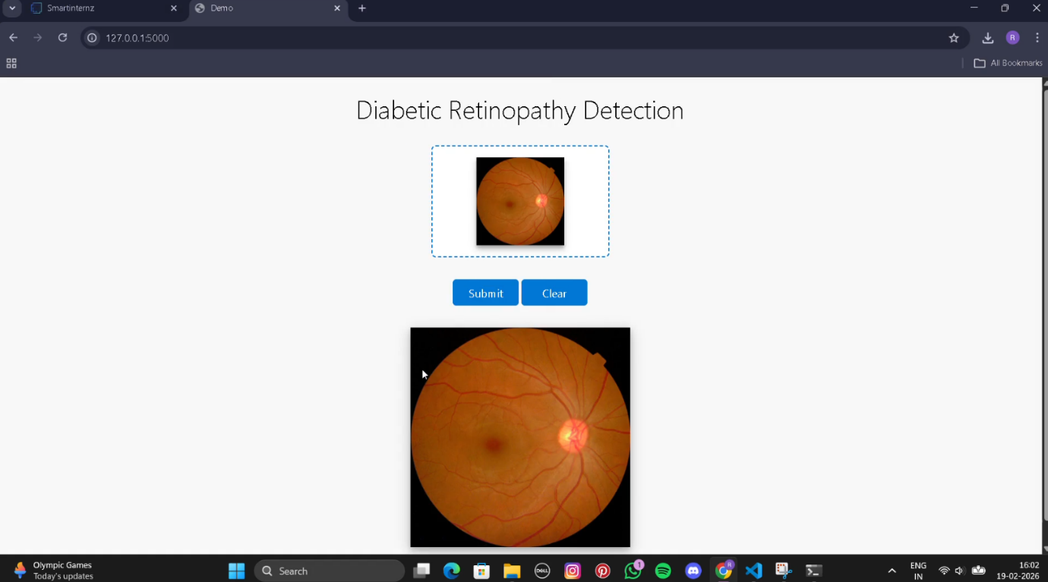

9. API Documentation
Endpoint 1: /predict
- Method: POST
- Parameters: file (image file) – retinal fundus image to be analyzed.
- Response: JSON object containing predicted class and message, or rendered HTML template.
Example Response:
{
"prediction": "Moderate Diabetic Retinopathy",
"class_index": 2,
"confidence": 0.85
}
Endpoint 2: /
- Method: GET
- Parameters: None
- Response: Renders index.html template with upload form.
10. Authentication
Current Status
- Open access.
- No login or authentication required.
- Anyone running locally can access.
Future Enhancements
- User Login System: Secure login for clinicians/patients.
- Role-Based Access Control (RBAC): Different permissions for admins, doctors, patients.
- API Key Authentication: For external API usage.

11. User Interface (UI)
Designed to be simple, clean, and user-friendly.
Technologies
- HTML (structure)
- CSS (styling/layout)
- Flask Templates (Jinja2)
- JavaScript (optional interactivity)
Pages
- Upload Page (index.html):
  - Image upload form.
  - Project title and description.
  - File input and upload button.
- Result Page (result.html):
  - Displays uploaded image.
  - Shows prediction (e.g., Moderate Diabetic Retinopathy).
  - Confidence score (optional).
  - Button to return and upload another image.
UI Characteristics
- Minimalist, intuitive layout.
- Responsive design.
- Clear call-to-action buttons
12. Testing
Unit Testing (Model)
- Verified Xception model accuracy.
- Evaluated confusion matrix, precision, recall, F1-score.
- Achieved satisfactory accuracy on validation/test sets.
API/Endpoint Testing
- GET / → Renders upload page.
- POST /predict →
  - Valid image → Correct prediction.
  - No file → Error message.
  - Invalid file type → Error message.
Functional Testing
- Navigation from upload to result page.
- Successful image upload.
- Correct prediction display.
- Error handling.
UI Testing
- Buttons functional.
- Forms submit correctly.
- Layout consistent across browsers.
- Error messages clear.
Integration Testing
- Verified integration between Flask backend, Keras model, preprocessing, and frontend templates.
13. Screenshots or Demo
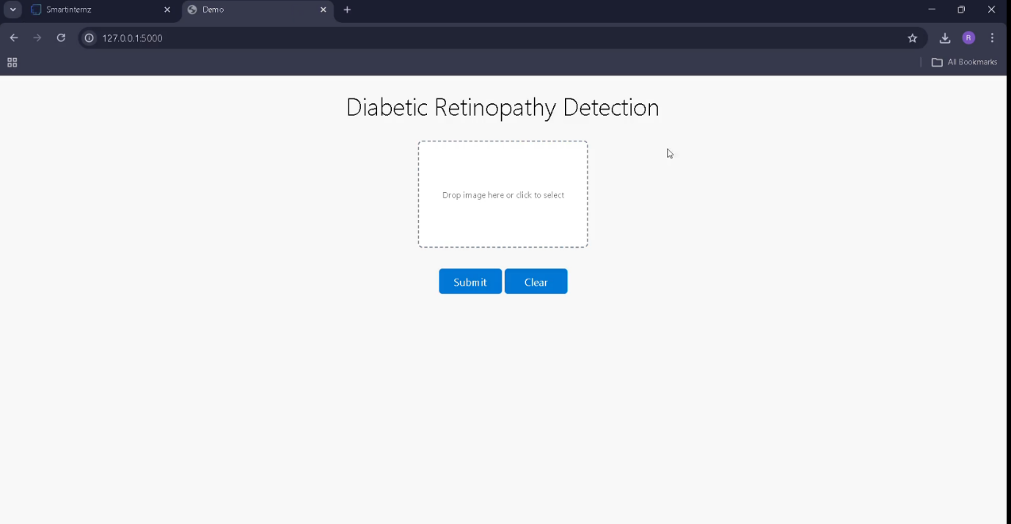
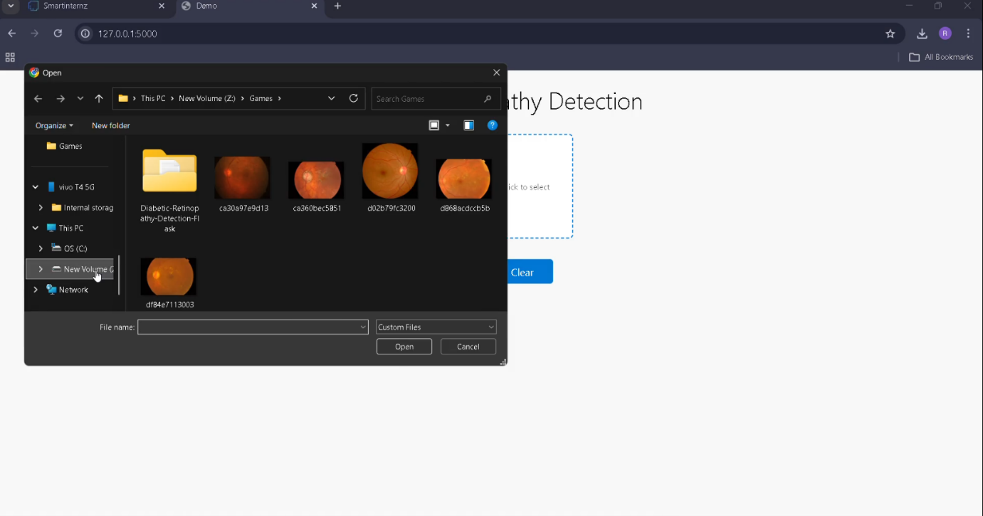

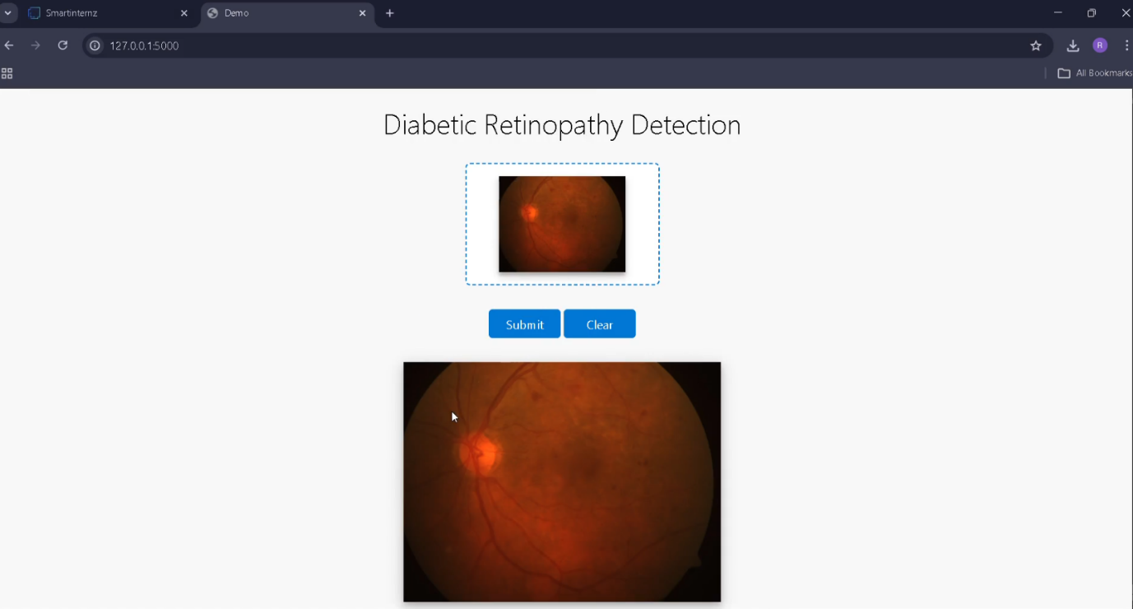

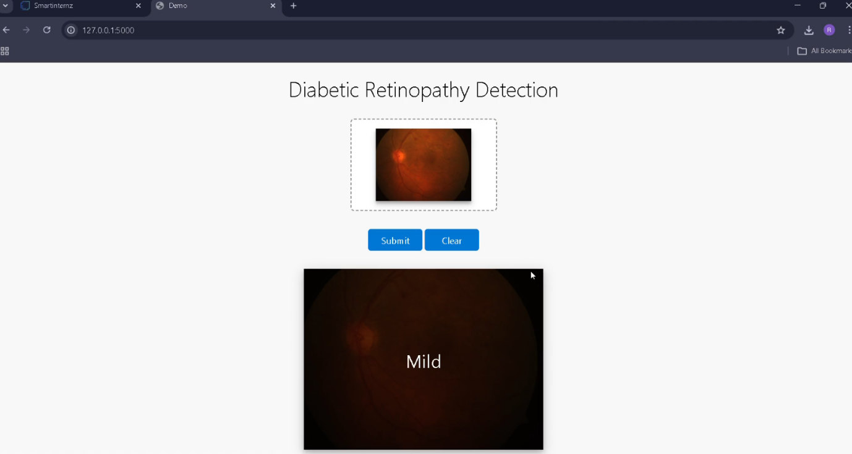

14. Known Issues
- Limited Dataset Diversity: May not generalize well.
Improvement: Train on larger, diverse datasets.
- Model Bias: Possible bias from training data.
Improvement: Analyze dataset, apply bias mitigation.
- No Authentication: Open access unsuitable for medical use.
Improvement: Implement secure login and RBAC.
- Local Execution Only: Runs only locally.
Improvement: Deploy on cloud (IBM Database).
- Lack of Explainability: Predictions not explained.
Improvement: Integrate XAI (e.g., Grad-CAM heatmaps).
- Basic Error Handling: Limited validation.
Improvement: Add robust error catching and logging.
12. Future Enhancements
Although the Deep Learning Fundus Image Analysis system works successfully, several improvements can make it more powerful, scalable, and industry-ready.
Explainable AI (XAI) Integration
- Current Limitation: Models act as “black boxes.”
- Future Improvement: Integrate Grad-CAM or similar techniques to generate heatmaps over uploaded images.
- Benefits: Highlights retinal regions (e.g., microaneurysms, hemorrhages) that influenced predictions, building clinician trust and aiding diagnosis.
Cloud Deployment
- Current Limitation: Runs locally only.
- Future Improvement: Deploy on cloud platforms (AWS SageMaker, Google Cloud, Azure).
- Benefits: Global accessibility, scalability, and usability for remote clinics.
JWT-Based Authentication & Multi-User Roles
- Current Limitation: No login system.
- Future Improvement: Implement secure login for patients, doctors, and admins with role-based permissions.
- Benefits: Secure access, patient data privacy, and audit trails.
Integration with Hospital Systems (EMR/EHR)
- Future Improvement: Develop APIs to connect with Electronic Medical Record systems.
- Benefits: Seamless workflow where images and predictions are automatically stored in patient records.
Support for Multiple Image Formats & Quality Check
- Future Improvement: Add support for DICOM format and automatic image quality assessment.
- Benefits: Professional-grade compatibility with medical imaging equipment and rejection of poor-quality inputs.
Larger and Multi-Center Dataset & Continuous Learning
- Current Limitation: Dataset size and diversity.
- Future Improvement: Partner with institutions to gather multi-source data and enable continuous learning with de-identified patient images.
- Benefits: Improved accuracy, robustness, and generalization across populations.
Mobile Application
- Future Improvement: Develop a mobile app (React Native/Flutter) connected to Flask backend or cloud API.
- Benefits: Enables point-of-care diagnosis using smartphone fundus cameras, expanding reach in rural areas.
Model Optimization & Comparison
- Future Scope: Experiment with architectures like EfficientNet, DenseNet, or Vision Transformers (ViTs).
- Benefits: Identify the best-performing model for deployment.

13. Conclusion

The Deep Learning Fundus Image Analysis for Early Detection of Diabetic Retinopathy project successfully demonstrates the application of deep learning and transfer learning in addressing a critical global health challenge.
By leveraging a pre-trained Xception model on retinal fundus images, the system achieves automatic classification of diabetic retinopathy severity, providing a foundation for faster, more accessible screening.
The integration of this model into a Flask-based web application creates a user-friendly tool where users can upload an image and receive instant analysis. This bridges the gap between complex AI models and practical usability, making the technology accessible to healthcare professionals, screening programs, and telemedicine platforms.
Through structured development and testing, the project confirms the feasibility of using AI for medical image analysis. Current limitations such as dataset diversity and lack of explainability highlight clear paths for future enhancements, including cloud deployment, XAI integration, and robust authentication.
Ultimately, this project serves as a proof-of-concept and scalable foundation for building a production-ready system. It stands as a compelling example of how combining deep learning, software engineering, and user-centric design can create a solution with profound potential to save sight and improve the quality of life for millions of diabetic patients worldwide.

